Perimeter

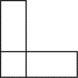
Two identical rectangular cards are glued together as shown, to form an 'L' shape.
The perimeter of this 'L' shape is 40 cm.
What can you say about the length and width of the original rectangles?

