Solving equations

Use your manipulating skills to solve these equations.
Solve the boxed ones using ‘Derive’ on the computers.

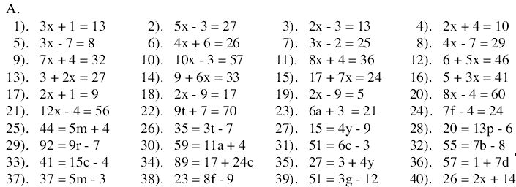

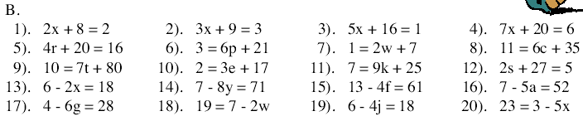

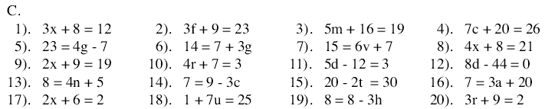

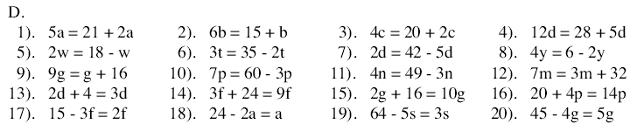

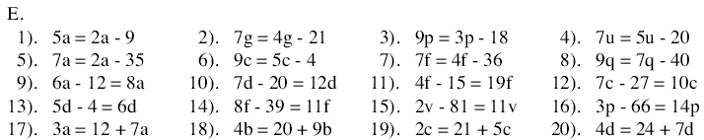

F.
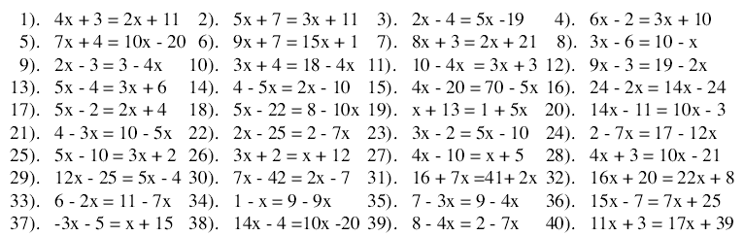

G.
