Functions

Increasing/decreasing graphs
Basic Graphs Worksheets
Linear
Quadratic
Cubic
Cube Root
Square Root
Rational
Absolute Value
Exponential
Logarithmic

Polynomials
End behavior
x-intercepts and behavior at them
Working backwards

Sequences
Notation
Domain and Range
Bounded Sequences

Appendices
Interval Notation
Factoring – The Guaranteed Method
Complete the Square Method
Factoring by Grouping

Homework

Increasing and decreasing graphs

We often talk of a turn-around point, a place where a graph “changes direction” from increasing to decreasing or vice versa…so it is important to be able to tell if a graph is increasing or decreasing.

When looking at the x’s we scan the graph left to right and we note that the smaller x’s are on the left. In fact, if we number the first x and the second x moving left to right, we have: .
Then we check the motion of the y values on the y axis as the x’s get larger and larger.

If the y values are moving UP the y axis as they get used, then the function is increasing. If the y values are moving DOWN the y axis as they get used, then the function is decreasing.

This has nothing to do with the sign of the y value – a graph can be in Quadrant 3 with negative numbers for x and y and still be increasing. For example:

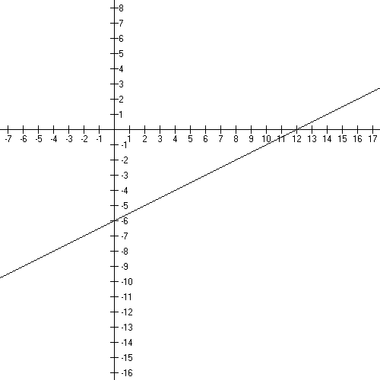
Here is the graph of y = .5x − 6.
It is increasing everywhere…even in Quadrant 3 and Quadrant 4 where the y’s are negative numbers.

Here is the graph of $f(x)=−x^{2}$. It is increasing on and decreasing for x’s beyond 0, . Note that you always specify where a graph is increasing or decreasing on intervals of the x axis, even though you’re talking about the behavior of the y values. The turn-around point is the vertex.
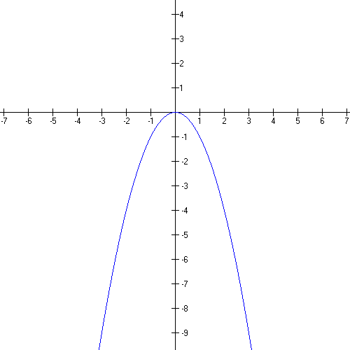

Here is the graph of $f(x)={\text{10}}^{x}$, an exponential graph. I’ve left the graph large so I can show you the motion on the y-axis. Let’s work it together.

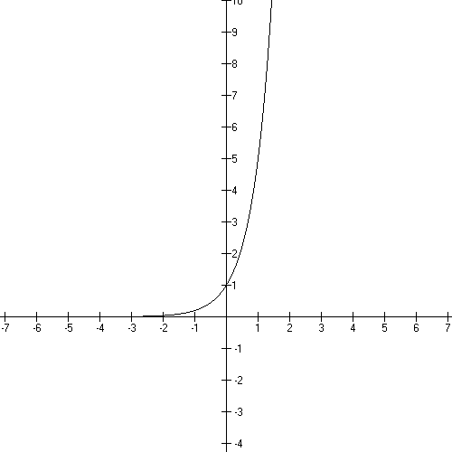

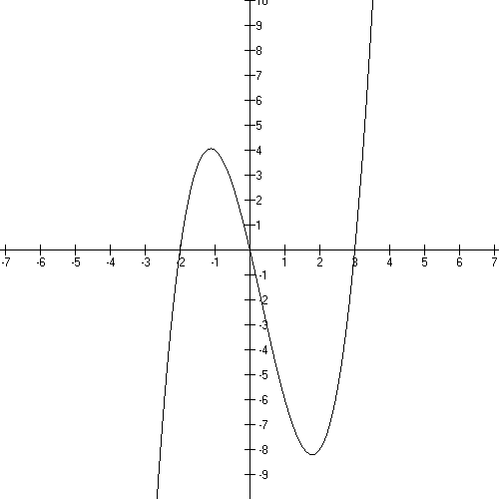
Here’s a polynomial.

There are two sections of
increasing and one of
decreasing…where are they?

Basic Graphs Worksheets

Basic Linear Function:

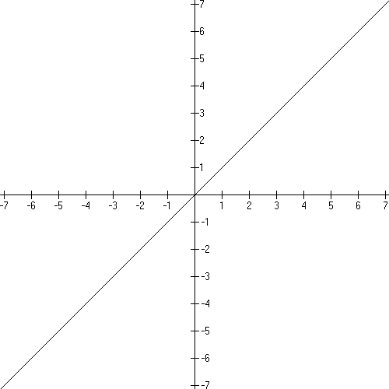

Domain:
Range:
x intercept: (0, 0)
y intercept: (0, 0)

Increasing everywhere.

This function is one-to-one.

Example of a shifted graph:

- shifting instructions: stretched by 3, left 2, down 1

- new formula:
try to get this yourself by working with the shifting instructions!

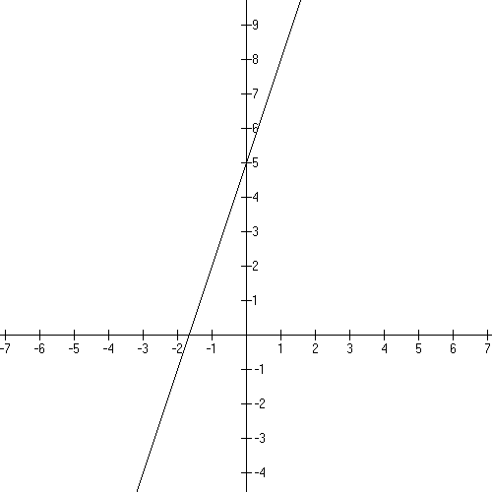
Domain:
Range:
x intercept: (−5/3, 0)
y intercept: (0, 5)

Linear Functions Review:

What is the linear function with x-intercept 5 that has (6, 9) also on the graph?
Is the graph increasing or decreasing?

What is the slope of the function: 15x − 3y = 12?
Is the graph increasing or decreasing?

Given (2, 3) and (9, 17), what is the equation of the line?
Is the graph increasing or decreasing?

Basic Quadratic function:

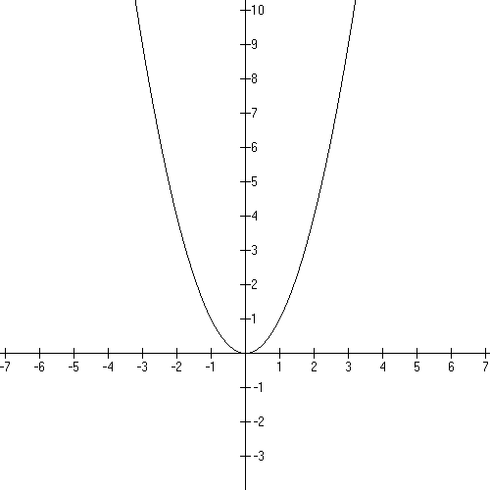
Domain:
Range:
x intercept: (0, 0)
y intercept: (0, 0)

Decreasing:
Increasing:

This function is not one-to-one.

Example of a shifted graph:

- shifting instructions: left 2, down 9

- new formula:

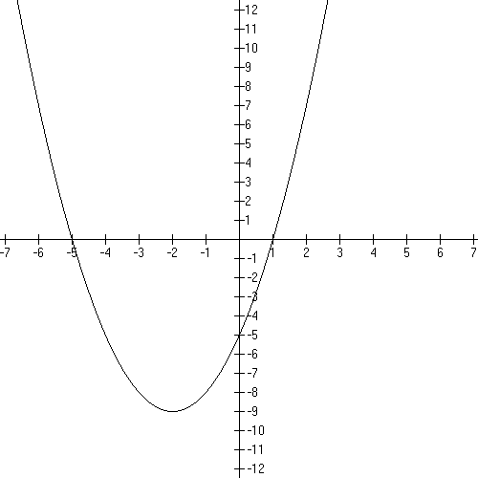

Domain:
Range:
x intercepts: (−5, 0) and (1, 0)
y intercept: (0, −5)

track the key point (0, 0) to (−2, −9)

decreasing $(−∞,−2)$
increasing $(−2,∞)$

Quadratic Functions Review:

Graph the function: $f(x)=(x−3)^{2}+4$ using graph shifting. Where is the vertex?
What are the intercepts? Where is the graphing increasing or decreasing?

Graph: $f(x)=(3−x)(x+4)$. Where is the vertex? Where is the graph increasing or decreasing?

Basic Cubic function:

$$f(x)=x^{3}$$

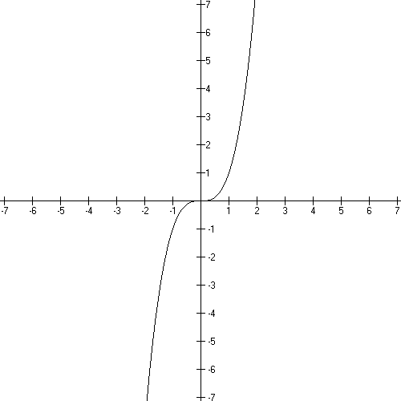
Domain: $(−∞,∞)$
Range: $(−∞,∞)$
x intercept: (0, 0)
y intercept: (0, 0)

Increasing everywhere.

This function is one-to-one.

Example of a shifted graph: ½ f(x − 1)

- shifting instructions: shrink by ½, right 1

- new formula: $f(x)=\frac{1}{2}(x−1)^{3}$

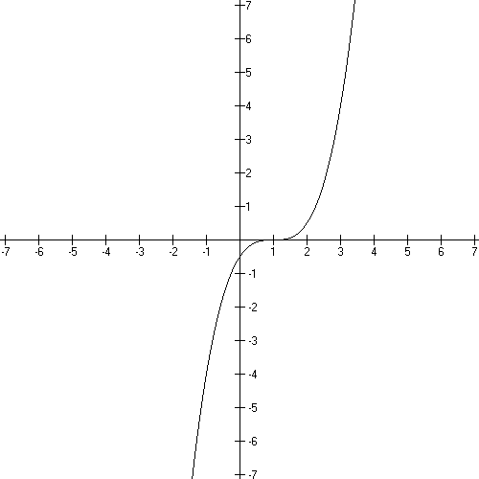
Domain: $(−∞,∞)$
Range: $(−∞,∞)$
x intercept: (1, 0)
y intercept: (0, −1/2)

track the key point (0, 0) to (1, 0)

Basic Cubic Review:

Give the domain and range for $f(x)=(x−1)^{3}$. Sketch the graph. Where is the graph increasing or decreasing?

Graph: $f(x)=−(x+3)^{3}−1$. Where is the graph increasing or decreasing?

Basic Cube Root function:

$$f(x)=\sqrt[3]{x}=x^{\frac{1}{3}}$$
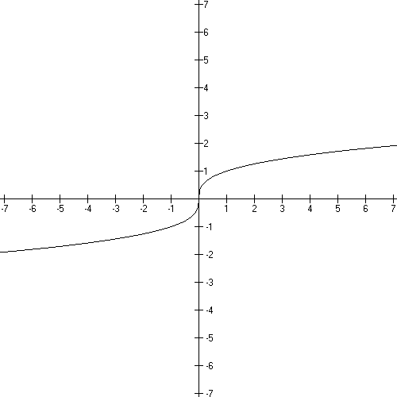
Domain: $(−∞,∞)$
Range: $(−∞,∞)$
x intercept: (0, 0)
y intercept: (0, 0)

Increasing everywhere.

This function is one-to-one.

Example of a shifted graph: f(x + 1) − 2

- shifting instructions: left 1, down 2

- new formula: $f(x)=(x+1)^{\frac{1}{3}}−2$

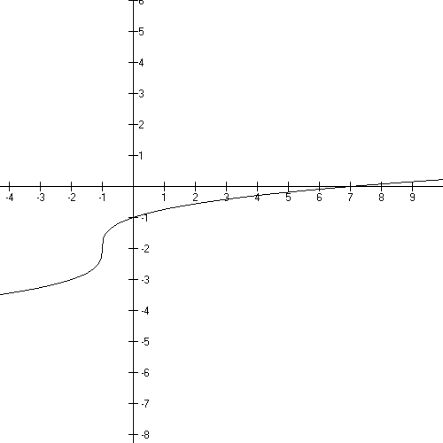

Domain: $(−∞,∞)$
Range: $(−∞,∞)$
x intercept: (7, 0)
y intercept: (0, −1)

increasing everywhere

track the key point (0, 0) to (−1, −2)

Basic Cube Root Review:

Graph $f(x)=−x^{\frac{1}{3}}$. Where is the graph increasing or decreasing?

Basic Square Root function:

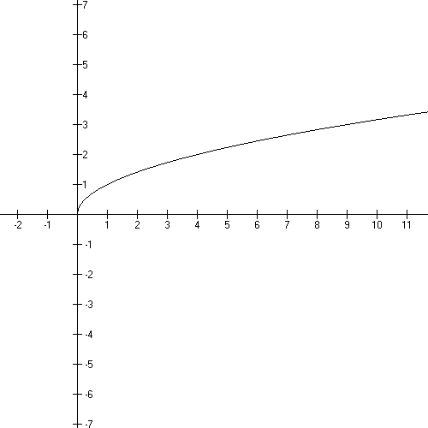
$$f(x)=\sqrt{x}=x^{\frac{1}{2}}$$

Domain:
Range: $[0,∞)$
x intercept: (0, 0)
y intercept: (0, 0)

Increasing on its domain.

This function is one-to-one.

Example of a shifted graph: −f(3 − x)

- shifting instructions: reflect about the x axis,
left 3,
reflect about the y axis

- new formula: $f(x)=−\sqrt{3−x}$

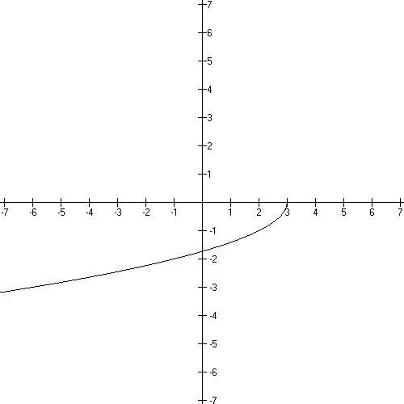

Domain: $(−∞,3]$
Range: $[0,∞)$
x intercept: (3, 0)
y intercept: $(0\text{.}−\sqrt{3} )$

increasing on it’s domain
Basic Square Root Review:

Graph $f(x)=\sqrt{9−x}$. Where are the intercepts? What is the domain and range?
Where is the graph increasing or decreasing?

Graph $f(x)=(x+4)^{\frac{1}{2}}$. Where are the intercepts? What is the domain and range?
Where is the graph increasing or decreasing?

Basic Rational function:

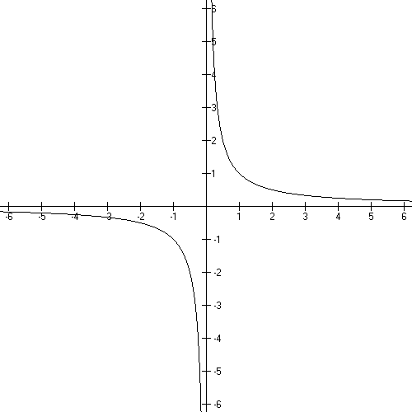
$$f(x)=\frac{1}{x}=x^{−1}$$

Domain: $(−∞,0)∪(0,∞)$
Range: $(−∞,0)∪(0,∞)$
x intercept: none
y intercept: none
vertical asymptote: x = 0
horizontal asymptote: y = 0

Decreasing on it’s domain

This function is one-to-one.

Example of a shifted graph: f(x + 2) - 3

- shifting instructions: left 2, down 3

- new formula:

try to get this yourself by working with the shifting instructions!
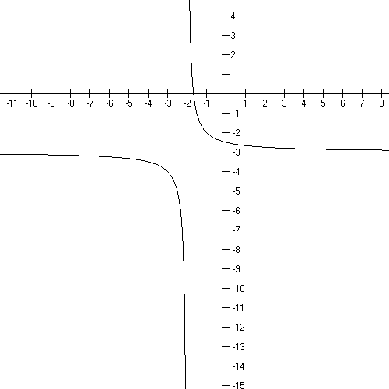

Domain: $(−∞,−2)∪(−2,∞)$
Range: $(−∞\text{.}−3)∪(−3,∞)$
x intercept: (−5/3, 0)
y intercept: (0, −5/2)
vertical asymptote: x = −2
horizontal asymptote y = −3

decreasing on it’s domain
Track the key point (1, 1) to (−1, −2).

Basic Rational Function Review:

More discussion on Asymptotes:

The disallowed values in the domain create vertical asymptotes….x = 0 is a vertical asymptote for this graph…the unattainable values in the range create horizontal asymptotes…y = 0 is a horizontal asymptote.

Asymptotes are lines that shape the graph. Graphs cannot cross a vertical asymptote – these create branches − but sometimes cross horizontal asymptotes… the graph resembles a horizontal line for x’s far down either end of the x axis when there’s a horizontal asymptote.

Let’s look at f(x) = $\frac{3x+7}{x+2}$

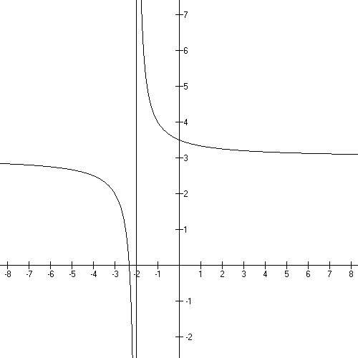

Domain:

What are the x and y intercepts?

Asymptotes:

VA:

Behavior at the VA:

HA:

End Behavior:

Note that around (−2, 3) the graph does NOT imitate
the asymptotes but far away from this point
it does look like these lines.

If you have a polynomial divided by a polynomial, you will have to identify and deal with all kinds of old ideas and new ideas…old ideas include x and y intercepts, new ideas are vertical and horizontal asymptotes and holes.

Vertical Asymptotes:

Linear factors in the denominator create vertical asymptotes unless they are cancelled with a like factor in the numerator…in which case, they create a hole.

Example:

What’s the difference between

$f(x)=\frac{x^{2}−\text{26}}{x+5}$ and $f(x)=\frac{x^{2}−\text{25}}{x+5}$

Well, x + 5 cancels out of the second function and not out of the first.

The first graph has a vertical asymptote at x = −5 … a vertical asymptote at the disallowed value, ie the point we leave OUT of the domain…

the second function has only a hole there….(recall cancellation creates a hole at x = −5

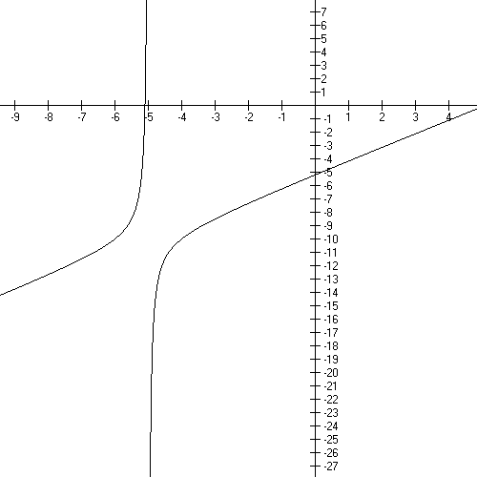

First function
$$f(x)=\frac{x^{2}−\text{26}}{x+5}$$

End Behavior:

At VA:

Second function – do the simplifying division and look at it again
$$f(x)=\frac{x^{2}−\text{25}}{x+5}$$

Let’s talk about the range here:

So when you have linear factors in the denominator you get a vertical asymptote or a hole. You get a
- vertical asymptote when it doesn’t cancel and a
- hole when it does cancel.

Now let’s review at Horizontal Asymptotes:

Basically you work off the leading terms. Divide the power of x in the numerator by the power of x in the denominator. See my handout on the website for more information and practice.

answer > 1 no horizontal asymptote

answer = 1 ha is ratio of coefficients n/d

answer < 1 x axis is horizontal asymptote

What is the HA for

What is the HA for

What is the HA for

Let’s look at some functions and tell what’s going on:

$$f(x)=\frac{x^{2}−x−2}{x^{2}−1}$$

Domain:

Vertical asymptotes:

Holes:

HA

x intercepts

y intercept

Sign chart
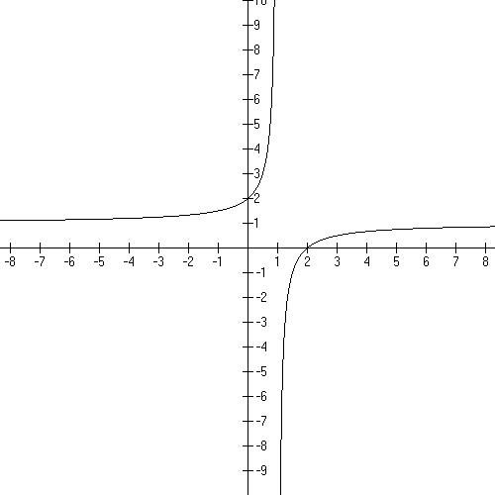

Graph:

End Behavior:

Behavior at the VA:

Another one:

Domain:

Vertical asymptote:

Holes:

HA

x intercepts

y intercept

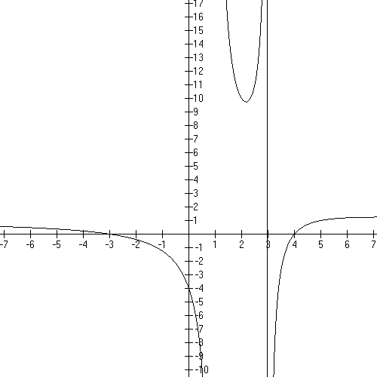
Graph

End behavior:

Behavior around the
asymptotes:

Let’s look at a deceptively simple one:

$f(x)=\frac{3}{x+5}$

Domain

VA

Holes

HA

x intercepts

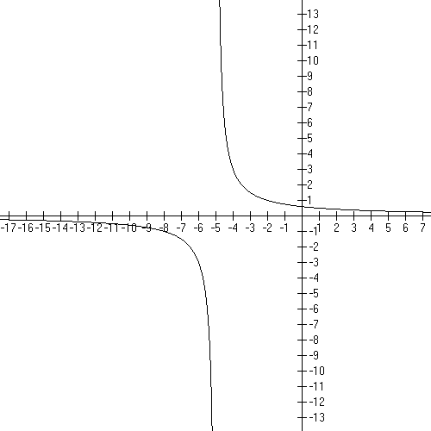
y intercept

graph

End behavior:

Behavior near asymptotes:

Hints and summaries

Zeros for the function are the zeros for the numerator after cancellation.
VA come from the zeros in the denominator after cancellation.
Factors that cancel create holes in the graph at the additive inverse of the number in the factor.
HA
n/d > 1 none
n/d = 1 ratio of coefficients
n/d < 1 x axis, y = 0

Tell me everything about $f(x)=\frac{x+6}{x−2}$ and sketch the graph.

Basic Absolute Value function:

$$f(x)=\left| x \right|$$
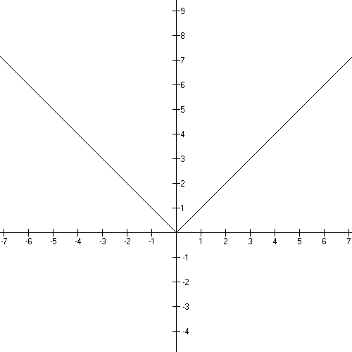
Domain: $(−∞,∞)$
Range: $[0,∞)$
x intercept: (0, 0)
y intercept: (0, 0)

Decreasing:
Increasing:

This function is not one-to-one.

Example of a shifted graph: −f(x − 5) +2

- shifting instructions: reflect about the x axis,
right 5, up 2

- new formula: $f(x)=−\left| x−5 \right|+2$

Domain: $(−∞,∞)$
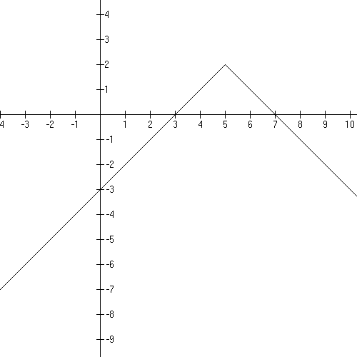
Range: $(−∞,2]$
x intercepts: (7, 0) and (3, 0)
y intercept: (0, −3)

increasing $(−∞,5)$
decreasing $(5,∞)$

Basic Absolute Value Review:

Where is the following function increasing and decreasing; show the graph.

$$f(x)=\left| x+3 \right|−2$$

Basic exponential function:

Domain: $(−∞,∞)$
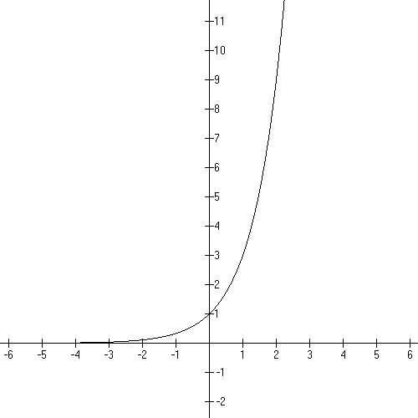
Range:
x intercept: none
y intercept: (0, 1)
horizontal asymptote: y = 0

Increasing everywhere.

(illustration is with b = 3)

Example of a shifted graph: −f(x + 3) + 9

- shifting instructions: reflect about the x axis,
left 3, up 9,

- new formula:

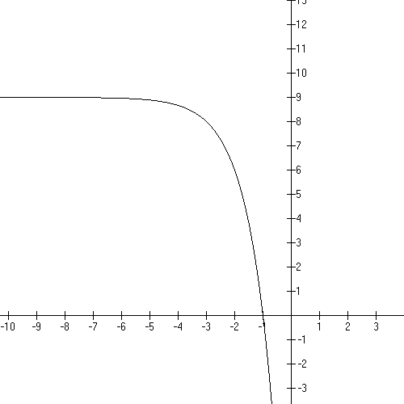

Domain: $(−∞,∞)$
Range:
x intercept: (−1, 0)
y intercept: (0, −18)
horizontal asymptote: y = 9

decreasing everywhere.

Be sure to know how to handle this
if b = e.
Basic Exponential Function Review:

Tell me everything about: $f(x)=3^{x}−9$

Basic logarithmic function:

$$f(x)={\text{log}}_{b}(x)$$
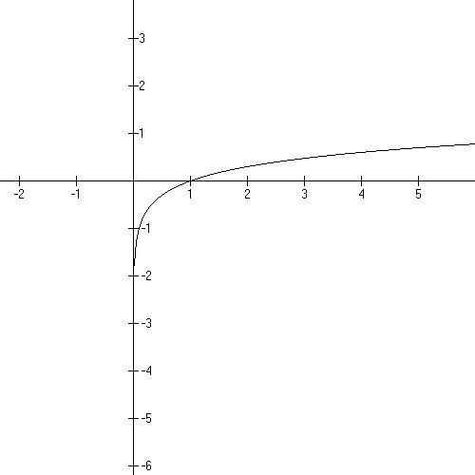
Domain:
Range:
x intercept: (0, 1)
y intercept: none

Vertical asymptote: x = 0

Increasing on its domain.

This function is 1:1.

(illustration is with b = 10)

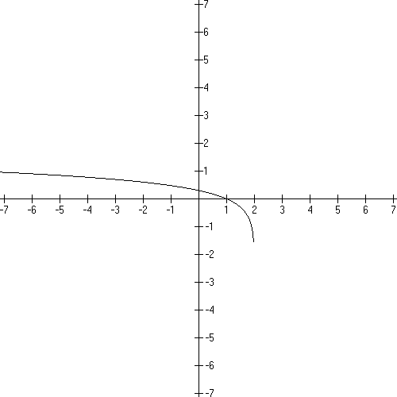

Example of a shifted graph:

- shifting instructions: left 2, reflect y

- new formula:

try to get this yourself by working with the shifting instructions!

Domain:
Range:
x intercept: (1, 0)
y intercept:

vertical asymptote: x = 2
decreasing on its domain

Basic Logarithmic Review:

Tell me everything about $f(x)={\text{log}}_{3}(x+9)$

Polynomials

A polynomial in x has one or more terms with a rational number coefficient and natural number power.

EXAMPLES:

a. $f(x)$= 3 = $3x^{0}$

b. $f(x)=x^{2}+5x+4=x^{2}+5x+4x^{0}=(x+4)(x+1)$

c.

d. $f(x)=−x^{7}−\text{49}x=−x^{7}−\text{49}x+0x^{0}$

The domain for every polynomial is all Real numbers. Always.

The y-intercept of the graph is f (0)…which is always the constant term (the term that
has the in it). Give the y-intercept of the polynomials in the example above:

The x-intercepts happen when the y value is zero. Replace f (x) with zero and solve for x. This always involves factoring. Note that the “zero” is the opposite sign of the
number in the factor. Give the x-intercepts of the examples above.

A. Behavior at the ends of the graph

The Leading Term is ${\text{ax}}^{n}$. The Leading Coefficient, a, can be negative or positive and it gives you graphing information. The Leading Power, n, can be even or odd and it gives you graphing information. The graphing information is about the ends of the graph way away from the origin.

Circle the leading term in each polynomial above.

Here’s a table of that information:

Graphing  Chart - Ends | n is even | n is odd
a is positive | $↑↑$
a is negative | $↓↓$

Mnemonic: + even
+ odd

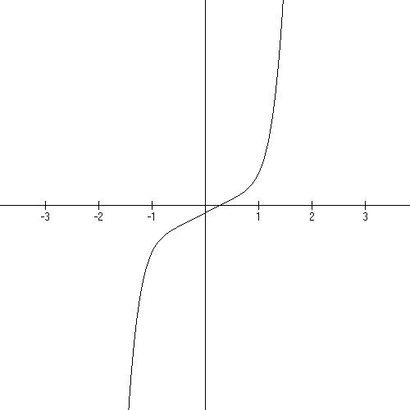
EXAMPLE 1: $f(x)=5x^{7}+\text{11}x−3$

Domain: All Real numbers

y-intercept: −3 as in (0, −3)

Ends: a is positive, n is odd:

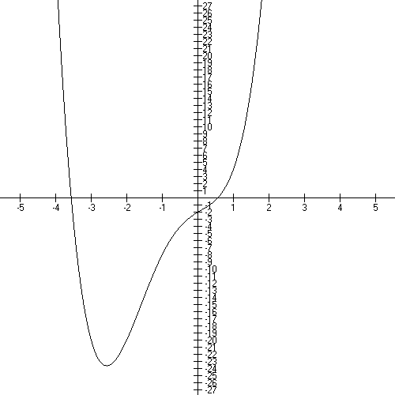
EXAMPLE 2:

$$f(x)=x^{4}+3x^{3}−x^{2}+3x−2$$

Domain: all Real numbers

y-intercept: −2

Ends: a is positive, n is even $↑↑$

B. x-intercepts

Note that both of the graphs above have x-intercepts. You find these by setting the polynomial to zero (y is always zero at an x-intercept) and factoring it to find the intercepts (aka: zeros).

EXAMPLE 3:

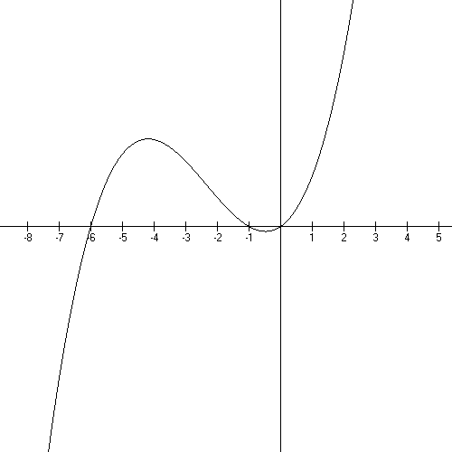
$$f(x)=x^{3}+7x^{2}+6x$$

Domain: all Real numbers

y-intercept: 0
(C is invisible!)

Ends: positive, odd

x-intercepts:

$$\begin{aligned}0=x^{3}+7x^{2}+6x \\ 0=x (x^{2}+7x+6) \\ 0=x (x+6)(x+1) \\ x=0, x=−6, \text{or} x=−1\end{aligned}$$

C. Behavior at x-intercepts

In example 3, the graph goes through each intercept locally just like a line. That happens because the exponent on each factor is 1.

The exponents on the factors tell you the local behavior of the graph at a intercept.

exponent is 1 graph goes through like a line

exponent is 2 graph curves back tangent to the x-axis like a parabola

exponent is 3 graph squiggles through the point like x-cubed

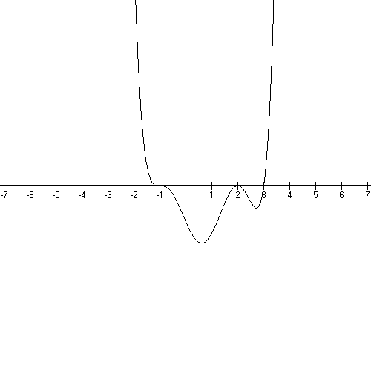
EXAMPLE 4:

$$f(x)=(x+1)^{3}(x−2)^{2}(x−3)=x^{6}+\text{.}\text{.}\text{.}−\text{12}$$

Domain: all Real numbers
y-intercept: 1(4)(−3)= −12

Ends: Positive, even $↑↑$

x-intercepts: −1 squiggle
2 parabola
3 line

D. Working backwards from the graph to the equation

EXAMPLE 5:

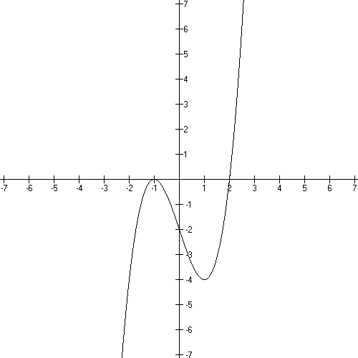
Leading term is positive.

−1 is an x-intercept and
the graph is locally like a parabola:

2 is an x-intercept and the
graph is locally like a line

$$f(x)=(x+1)^{2}(x−2)$$

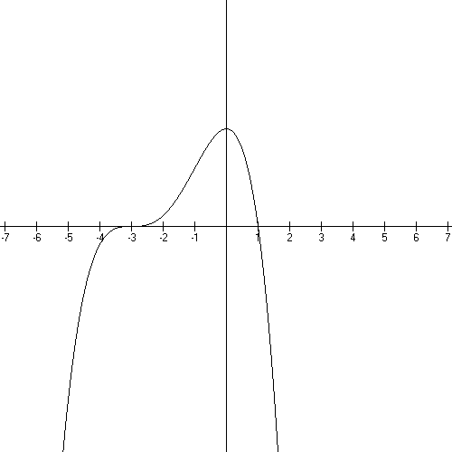
EXAMPLE 6:

Leading term is negative.

at −3 the graph is a squiggle.
at 1 the graph is a line.

$$f(x)=−(x+3)^{3}(x−1)$$

Sequences*

a good source:
*Cohen, David Precalculus, 5th edition West Publishing isbn 0-314-06921-6

A numerical sequence is a function with a domain of the natural numbers. A single element of the range is called a term of the sequence. Some sequences are finite – the number of terms is a given natural number and some are infinite.

Very often the terms are indexed by the natural numbers…the indices are the domain numbers.

EXAMPLE 1: A sequence with a formula

This is an infinite sequence bounded below by ½ , which is a function point and above by 1 which is not. Each is a y-value and each n is the associated x.

[Sometimes the function has the whole numbers as it’s domain and the indexing starts with 0.]

Write this sequence as point pairs and then graph them. Show where the bounds are and label those. Write out the domain and range in words. Is this a function? How do you know?

EXAMPLE 2:

What are the point pairs? Are there bounds? What is the domain and range (in words)?
Is this a function? How do you know?

Recursive sequences

Sometimes, the next term in a sequence is defined by a preceding term or two, these are called recursive sequences.

B

The sequence is: 3, 4, 6, 10, 18, 34, 66, 130, 258, 514
These are range elements. The domain elements are given in the inequality above.
This is a finite sequence.

Write the point pairs, graph and discuss bounds.

The Fibonacci sequence is an infinite recursive sequence.

Arithmetic Sequences

If you begin your sequence with a given number and then add a fixed number to each succeeding term, then you’ve made an arithmetic sequence.
The pattern is: a is given as the first term and d will be what is added to each succeeding term:

a, a + d, a + 2d, a + 3d, a + 4d, …

The pattern allows us to come up with a formula for the nth term:

Which gives some interesting problems. Show the point pairs, discuss if it’s a function. What are the domain, range and bounds?

EXAMPLE 4

Given the arithmetic sequence: 7, 10, 13, 16, …. What is the 100th term?

a = 7 d = 3

List point pairs, graph, discuss domain, range and bounds.

EXAMPLE 5

Give the details of the arithmetic sequence with a second term of −2and an eighth term of 40.

is the general formula

I know

−2= a + (2−1)d and 40 = a + (8−1)d

So I can get a and d.

−2 = a + d
40 = a + 7d

multiply the second equation by −1…add them….−42 = −6d so d = 7 and a = −9.

This is all we need to specify to give the details.

List 10 point pairs, graph and discuss domain, range, and bounds. Is it a function? How do you know?

Geometric Sequences

A geometric sequence is a sequence of the form:

The nth term is then:

EXAMPLE 6

1, ½, ¼, 1/8, …, what are a and r?

10, −100, 1000, −10,000 … what are a and r?

These graph as points in the plane, in Quadrants 1 and sometimes IV.

