Name:

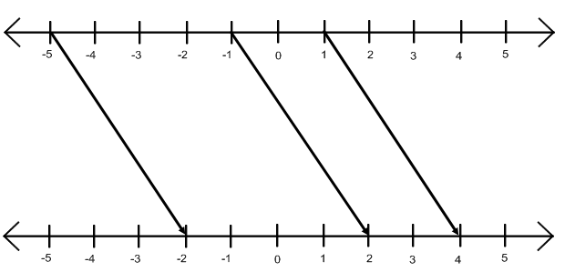

Fill in the table for the mapping diagram above:

Inputs
Outputs

What do you think the function could be?

x → _____________

Can you fill in the missing lines on the mapping diagram and the outputs in the table?

What do you notice about the lines?

Name:

Fill in the table for the mapping diagram above:

Inputs
Outputs

What do you think the function could be?

x → _____________

Can you fill in the missing lines on the mapping diagram and the outputs in the table?

What do you notice about the lines?

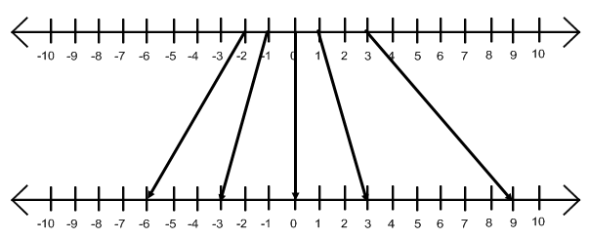
Fill in the table for the mapping diagram above:

Inputs
Outputs

What do you think the function could be for this diagram?

x → _____________

Fill in the missing lines for inputs of -3 and 2 on the diagram, and add the outputs to the table.

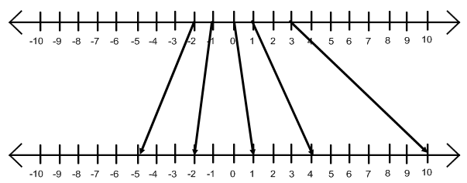
This diagram is a two-step function – can you think what it could be?

x →
Fill in the table for the mapping diagram above:

Inputs
Outputs

What do you think the function could be for this diagram?

x → _____________

Fill in the missing lines for inputs of -3 and 2 on the diagram, and add the outputs to the table.

This diagram is a two-step function – can you think what it could be?

x →

