Green | Amber | Red
Complete this table for the graph  Y = ½ x - 2  X 0 1 2 3 4  y | Complete this table for the graph  y = 2x + 2  X 0 1 2 3 4  Y | Complete this table for the graph  x + y = 3  X 0 1 2 3 4  y
What is the y intercept for the line  y = 3x – 5 | What is the gradient for the line  y = 7 – 2x | What is the gradient for the line  y = 3x + 2
Are the two lines parallel? Give a reason.  y = 2x - 4  y = -2x + 3 | Are the two lines parallel? Give a reason.  y = 3x - 4  y - 3x = 2 | Are the two lines parallel? Give a reason.  y = 2x - 5  y = 5x – 5
What is the equation of this line?  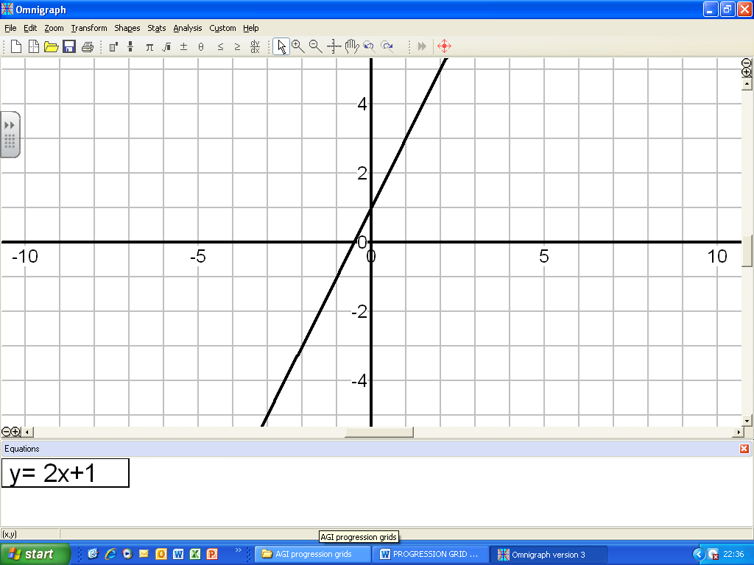 | What is the equation of this line? 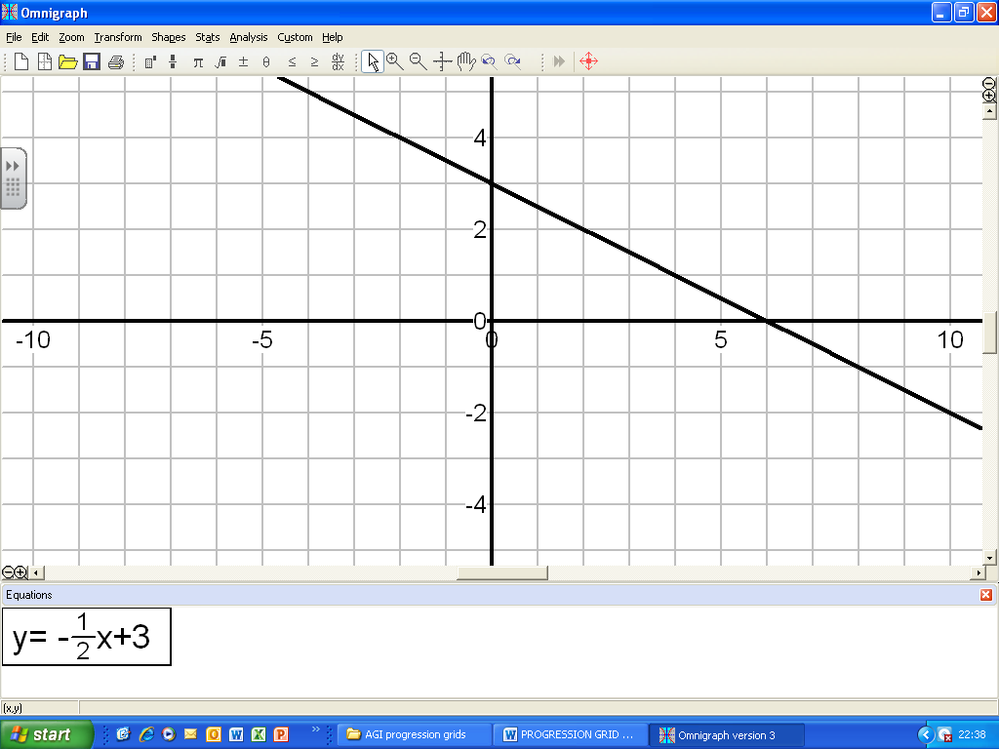 | What is the equation of this line?  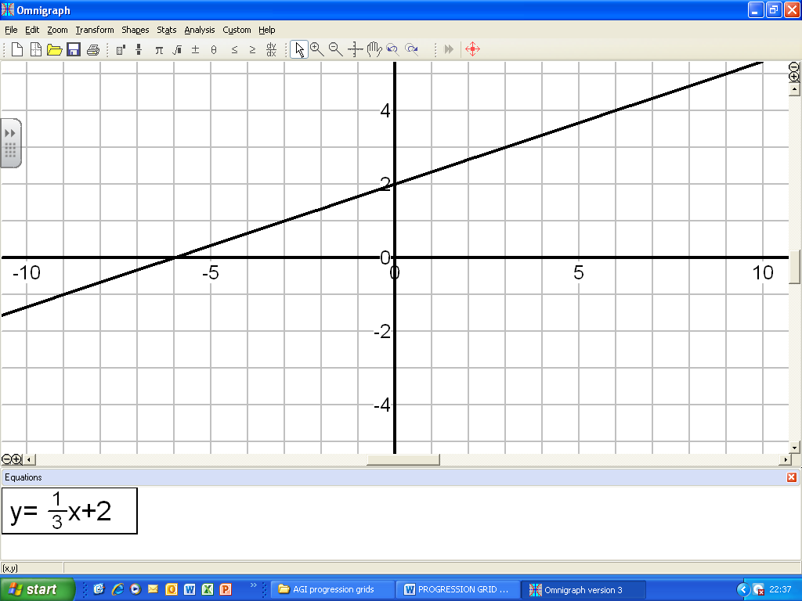
Are the two lines parallel?  Give a reason  2y – 10x = 4  y – 2 = 5x | Do these lines have the same y intercept? Explain why.  y = 2x – 2  y + 3 = x | What is the gradient of the line joining  (-2, 7) and (4, -2)
Are the two lines perpendicular?  Give a reason  y = 2x - 4  y = -2x + 3 | Are the two lines perpendicular?  Give a reason  y = ½ x - 7  y = 7 - 2x | Are the two lines perpendicular?  Give a reason  y + ¼ x =7  y + 2 = 4x

