Finish the graph to describe each situation. You can decide the exact details.

- The train waits longer than usual at station B.

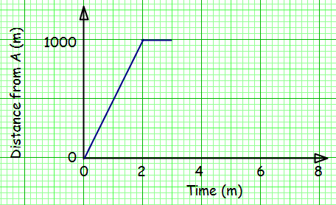
How long does your train spend in total at B?

______________________

- The train returns more slowly than normal.

Bonus question: what is the speed of your train on the return journey?

______________________

- The driver sets off from B, but forgets something. So the train goes back to B to get it, then continues to A at the usual speed.

How much time in total is wasted?

______________________

- The train breaks down at some point on the return journey (you decide whether it gets fixed!)

Can you give a reason for the shape of your graph?

________________________

________________________

________________________

Draw a graph to describe each situation:

