Input Output Input Output

A V N O

B F O C



C Q P J

D Y Q P

E L R H

F I S E

G K T S

H Z U W

I A V M

J N W X

K B X D

L R Y T

M G Z U

Input Output Input Output

A V N O

B F O C



C Q P J

D Y Q P

E L R H

F I S E

G K T S

H Z U W

I A V M

J N W X

K B X D

L R Y T

M G Z U

>>>CHALLENGE

a) List the integer values of *x* such that

–2  *x* < 3

........................................................................................................................

........................................................................................................................

Answer ....................................................

(2)

(b) Solve the inequality

*x*2 > 64

........................................................................................................................

........................................................................................................................

Answer ....................................................

(2)

(Total 4 marks)

>>>CHALLENGE

a) List the integer values of *x* such that

–2  *x* < 3

........................................................................................................................

........................................................................................................................

Answer ....................................................

(2)

(b) Solve the inequality

*x*2 > 64

........................................................................................................................

........................................................................................................................

Answer ....................................................

(2)

(Total 4 marks)

(a) Solve the inequality 3*x –* 5  5 – *2x*

........................................................................................................................

........................................................................................................................

........................................................................................................................

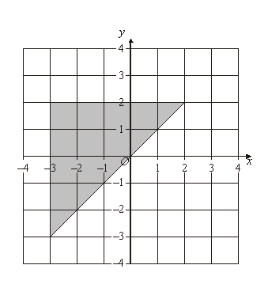Answer .......................................................

(2)

(b) The region *R* is shown shaded below.

Write down **three** inequalities which together describe the shaded region.

........................................................................................................................

........................................................................................................................

........................................................................................................................

Answer .......................................................

(Total 5 marks)

(a) Solve the inequality 3*x –* 5  5 – *2x*

........................................................................................................................

........................................................................................................................

........................................................................................................................

Answer .......................................................

(2)

(b) The region *R* is shown shaded below.

Write down **three** inequalities which together describe the shaded region.

........................................................................................................................

........................................................................................................................

........................................................................................................................

Answer .......................................................

(Total 5 marks)