Green | What is the largest possible value for n if:  n ≤ 3 | Write the inequality shown on the number line below:  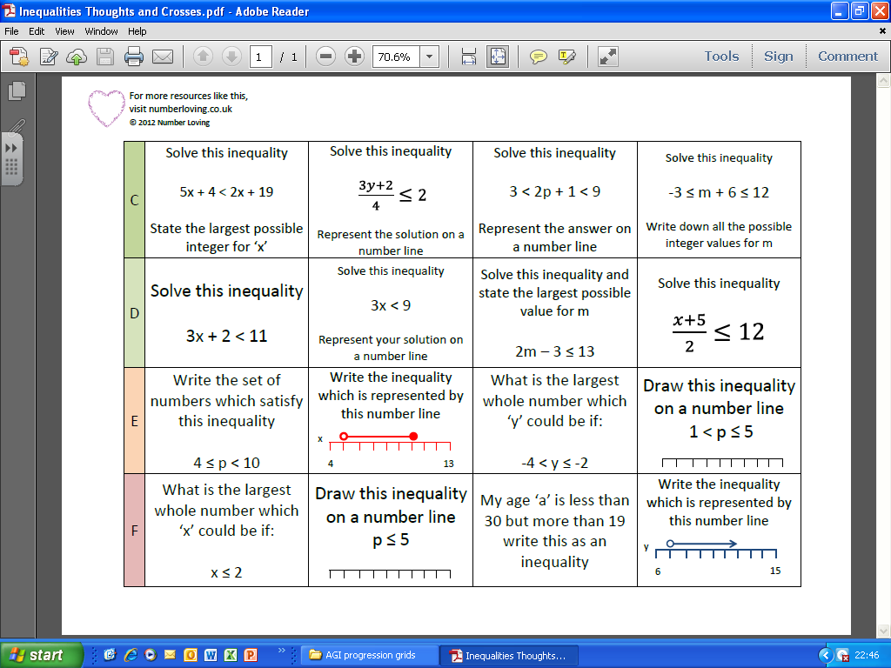 | Anne’s age, a, is greater than 20 and less than 27.  Write this as an inequality. | Write the inequality shown on the number line below:
Amber | List the integer values which satisfy  -3 < n ≤ 4 | Display this inequality on a number line  -1 ≤ n < 5 | List the integer values which satisfy  -5 ≤ n ≤ 1 | Display this inequality on a number line  -4 < n < 2
Red | Solve the inequality  3x + 2 $≥$ 11  If x is an integer, what is the smallest possible value for x? | Solve the inequality  3x < 9  Display your answer on a number line. | Solve the inequality  2n – 3 ≤ 33  If n is an integer, what is the largest possible value for n? | Solve the inequality  $$\frac{x+5}{2}≥10$$  Display your answer on a number line.
Challenge | Solve the inequality  5n + 4 ≤ 2n + 19  If n is an integer, what is the largest possible value for n? | Solve the inequality  2 < 3n < 12  If n is an integer, list all the possible values for n. | Solve the inequality  -3 < n + 6 < 12  If n is an integer, list all the possible values for n. | Solve the inequality  3 < 2n + 1 < 9  Display your answer on a number line.

