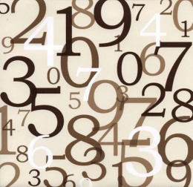**Sequences**

Objective : to be able find term- to – term rules for sequences

Starter questions

**If I have 1p and double it every day, how long will it be until I have £5?**

What is a square number? List the first 12 square numbers

What is a prime number? Can you list the first 20 prime numbers?

**Main questions**

1. Copy down the following sequences and add the next three terms:
   1. 3 6 9 12 15
   2. 2 7 12 17 22
   3. 4 10 16 22 28
   4. 13 24 35 46 57
   5. 50 48 46 44 42
2. For each of the questions in question what is rule to find the next term in the sequence. (This is called the term to term rule)
3. Copy the following sequences, write the term to term rule and find the next 3 terms.
   1. 0.3 0.7 1.1 1.5 1.9
   2. 1.4 1.7 2 2.3 2.6
   3. 40 39.5 39 38.5 38
   4. 5.9 5.3 4.7 4.1 3.5
   5. 11.4 12.5 13.6 14.7 15.8
4. Copy the following sequences, write the term to term rule and find the next 3 terms.
   1. 5 0 -5 -10 -15
   2. 3 -1 -5 -9 -13
   3. -20 -16 -12 -8 -4
   4. -30 -27.5 -25 -22.5 -20
5. Copy the following sequences, write the term to term rule and find the next 3 terms.
   1. 1 2 4 8 16
   2. 1 3 6 10 15
   3. 1 3 7 13 21

**Star questions**

This sequence has the rule “double the last number and add 1”:

1 3 7 15 31.

Can you find the rules for these sequences (they all have 2 parts like the example)

1. 1 3 11 43
2. 1 4 10 22
3. 2 10 26 58