Higher Substitution Questions

For each dinosaur calculate their strength, speed, size and intelligence.

Section A)

For these dinosaurs, a = 4, b = 3, c = 1, d = 2

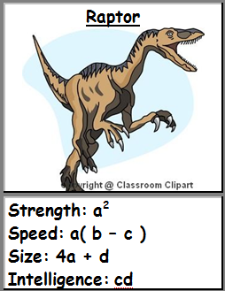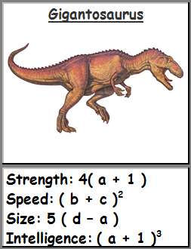

Section B)

For these dinosaurs, a = 2, b = -1, c = 4, d = 5

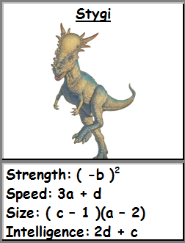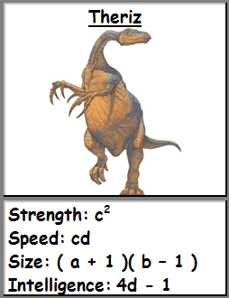

Section C)

For these dinosaurs, a = -3, b = 3, c = 2, d = -2

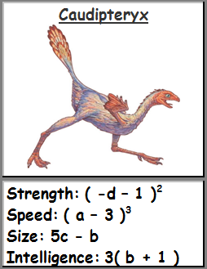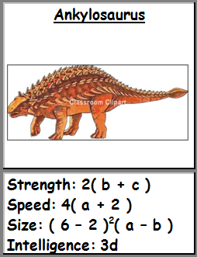

Section D)

For these dinosaurs, a = 2, b = 0, c = -2, d = 1

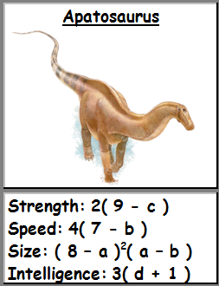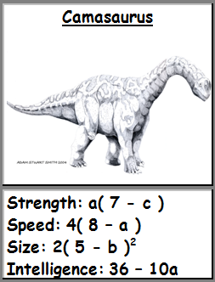

Section E)

For these dinosaurs, a = -1, b = 3, c = -2, d = 2

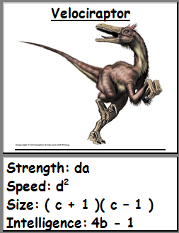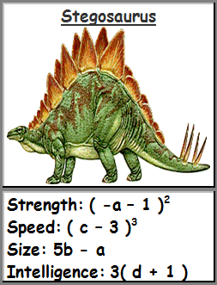

Section F)

For these dinosaurs, a = 0, b = 7, c = -1, d = 1

