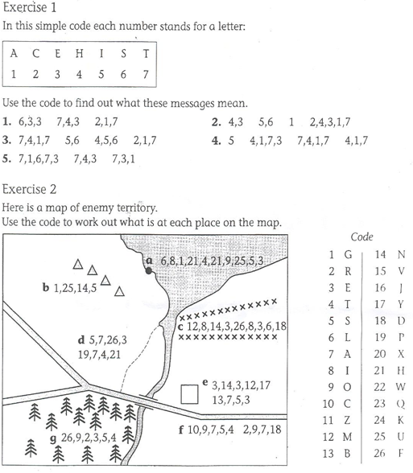

**Exercise 1**

**1:**

**2:**

**3:**

**4:**

**5:**

**Exercise 2**

**a:**

**b:**

**c:**

**d:**

**e**

**f:**

**Name:**

**Objective: to be able to represent letters as numbers**