**HCF and LCM Using Venn Diagrams**

1. Work out the prime factorisation of each number.

2. Arrange the numbers in the Venn diagram

3. Write down the HCF and the LCM of each pair of numbers.

**EXAMPLE:**

Find the HCF and the LCM of 24 and 60.

**1. Prime Factorisation**

|  |  |
| --- | --- |
| **24** | **60** |

**2. Venn Diagram**

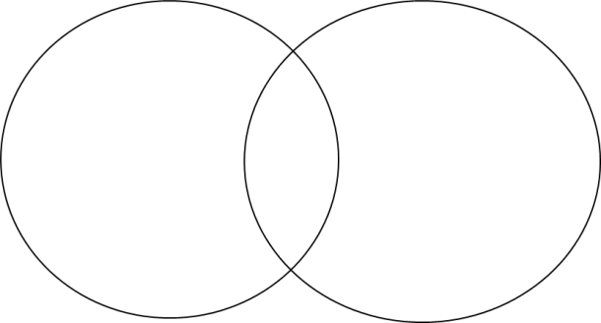

**REMEMBER:**

HCF is the numbers in the intersection multiplied together

LCM is all the numbers in both circles multiplied together

**Questions to Complete Using the Venn Diagram Worksheet**

**1. Find the HCF and LCM of 10 and 15**

**2. Find the HCF and LCM of 12 and 28**

**3. Find the HCF and LCM of 28 and 42**

**4. Find the HCF and LCM of 48 and 64**

**5. Find the HCF and LCM of 15 and 25**

|  |  |
| --- | --- |
| **Prime Factorisation of 10** |  |
| **Prime Factorisation of 15** |  |
| **HCF** |  |
| **LCM** |  |

|  |  |
| --- | --- |
| **Prime Factorisation of 12** |  |
| **Prime Factorisation of 28** |  |
| **HCF** |  |
| **LCM** |  |

|  |  |
| --- | --- |
| **Prime Factorisation of 28** |  |
| **Prime Factorisation of 42** |  |
| **HCF** |  |
| **LCM** |  |

|  |  |
| --- | --- |
| **Prime Factorisation of 48** |  |
| **Prime Factorisation of 64** |  |
| **HCF** |  |
| **LCM** |  |

|  |  |
| --- | --- |
| **Prime Factorisation of 15** |  |
| **Prime Factorisation of 25** |  |
| **HCF** |  |
| **LCM** |  |

**6. Find the HCF and LCM of 12 and 32**

**7. Find the HCF and LCM of 42 and 63**

**8. Find the HCF and LCM of 18 and 24**

**9. Find the HCF and LCM of 24 and 56**

**10. Find the HCF and LCM of 42 and 27**

|  |  |
| --- | --- |
| **Prime Factorisation of 12** |  |
| **Prime Factorisation of 32** |  |
| **HCF** |  |
| **LCM** |  |

|  |  |
| --- | --- |
| **Prime Factorisation of 42** |  |
| **Prime Factorisation of 63** |  |
| **HCF** |  |
| **LCM** |  |

|  |  |
| --- | --- |
| **Prime Factorisation of 18** |  |
| **Prime Factorisation of 24** |  |
| **HCF** |  |
| **LCM** |  |

|  |  |
| --- | --- |
| **Prime Factorisation of 24** |  |
| **Prime Factorisation of 56** |  |
| **HCF** |  |
| **LCM** |  |

|  |  |
| --- | --- |
| **Prime Factorisation of 42** |  |
| **Prime Factorisation of 27** |  |
| **HCF** |  |
| **LCM** |  |