Prime Factors, LCM and HCF

Review:

What is the Lowest Common Multiple?

* the lowest number in two or more numbers’ times tables.

Ex.  ***What is the LCM of 4 and 6?***

1. Write out the first six numbers the 4 and 6 times tables
2. Look for the first number that appears in both lists.
3. 🡪 4, 8, 12, 16, 20, 24,….
4. 🡪 6, 12, 18, 24, 30, 36,…

The LOWEST common multiple of 4 and 6 is… **12.**

What is the Highest Common Factor?

- the largest number that goes into two or more numbers exactly.

Ex. ***What is the HCF of 32 and 56?***

1. Write out all the factors of 32 and 56 in order

2.Look for the first number that appears in both lists.

32 🡪 1, 2, 4, 8, 16, 32

56 🡪 1, 2, 4, 7, 8, 14, 28, 56

The HIGHEST common factor of 32 and 56 is… **8**.

What is a prime factor?

-A number that has exactly two factors

Ex. Use the factor tree to find the prime factors of 84.

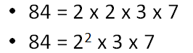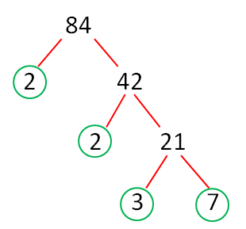

**Complete all of the questions below. Record your work for 2 questions from each section in your maths books.**

Lowest Common Multiple

Find the Lowest Common Multiple for these groups of numbers

1. 3, 4
2. 4, 9
3. 2.2, 5
4. 4, 5, 9
5. 5, 8, 16

Highest Common Factor

Find the Highest Common Factor for these groups of numbers

1. 4, 6
2. 6, 12
3. 19, 26
4. 9, 12, 24
5. 14, 21, 49

Prime Factors

Use the factor tree to express each of these numbers as a product of it’s prime factors:

1. 28
2. 78
3. 57
4. 72
5. 112

**Activity:**

Your challenge is to create a game based on either lowest common multiples (LCM), highest common factors (HCF), or prime numbers. This game should allow the player(s) to practice their knowledge of LCM, HCF or prime numbers.

Be creative. You can use any resources available in the classroom. You will have Wednesday and Thursday’s maths lessons to complete your game.