1. Here is a sorting diagram for numbers.
Write a number less than 100 in each space.
 | even | not even
a square number
not a square number

2. Find two square numbers that total 45
+ = 45

3. Circle the two prime numbers.
29 39 49 59 69

4. Write all the numbers between 50 and 100 that are factors of 180
...........................................................

5. Write all the factors of 30 which are also factors of 20
.................................................................................................................................

6. Write these numbers in the correct places on the diagram.
5 6 7 8

7. Here is a number chart.
Circle the smallest number on the chart that is a multiple of both 2 and 7
71 | 72 | 73 | 74 | 75 | 76 | 77 | 78 | 79 | 80
81 | 82 | 83 | 84 | 85 | 86 | 87 | 88 | 89 | 90
91 | 92 | 93 | 94 | 95 | 96 | 97 | 98 | 99 | 100

Here is the same number chart.
Circle the largest number that is not a multiple of 2 or 3 or 5
71 | 72 | 73 | 74 | 75 | 76 | 77 | 78 | 79 | 80
81 | 82 | 83 | 84 | 85 | 86 | 87 | 88 | 89 | 90
91 | 92 | 93 | 94 | 95 | 96 | 97 | 98 | 99 | 100

8. Here is a diagram for sorting numbers.
Write one number in each white section of the diagram.
 | less  than 1000 | 1000  or more
multiples
of 20
not multiples
of 20

9. Write these numbers in the correct places on the Venn diagram.
Some numbers are already placed.
99 170 221

10 Millie and Ryan play a number game.

What's my number?

Is it under 20? Yes
Is it a multiple of 3? Yes
Is it a multiple of 5? Yes

What is the number?
……………………………….

They play the game again.

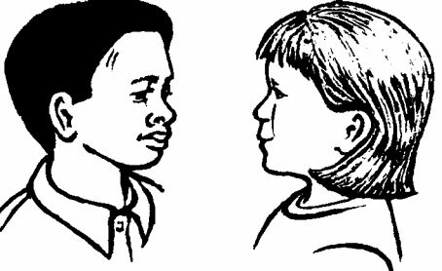
Is it under 20? No
Is it under 25? Yes
Is it odd? Yes
Is it a prime number? Yes

What is the number?
……………………………

11. Here is a diagram for sorting numbers.
Write these three numbers in the correct boxes.
You may not need to use all of the boxes.
9 17 20

12. Here are four labels.
Write each label in the correct position on the sorting diagram below.
 | 72  54 | 56  84
 | 63  45 | 49  75

