**1.** Draw lines to join **all the pairs** of number cards which have a **difference of 30**

One has been done for you.

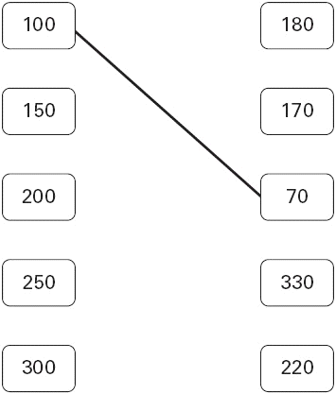

2 marks

**2.** Circle the numbers that add up to 100

64 32 16 8 4 2 1

1 mark

**3.** Write in the missing numbers.

 + 85 = 200

1 mark

4 ×  = 120

1 mark

120 – 51 = 

1 mark

**4.** Calculate **127 + 57**

|  |
| --- |
|  |

1 mark

**5.** Draw a line to join two other numbers which have a **total** of **700**

 1 mark

**6.** Circle **three** numbers which **add** to make **190**

**10** **30** **50** **70** **90**

1 mark

**7.** Here are some number cards.



Use **five of the number cards** to make this correct.



2 marks

**8.** Calculate **309 –198**

|  |
| --- |
|  |

1 mark

**9.** Draw lines to join the circle to **two more** number cards which make **150**



2 marks

**10.** Calculate **448 + 375**

|  |
| --- |
|  |

1 mark

**11.** There are **5 balloons** in a **packet**.

There are **18 packets** in a **box**.



How many balloons are there altogether in a **box?**

|  |
| --- |
|  |

1 mark

There are 5 balloons in a packet.

Kofi needs **65 balloons**.

How many **packets** does he need?

|  |
| --- |
|  |

1 mark

**12.** Here are five digit cards.



Use all five digit cards once to make this sum correct.



1 mark

**13.** Each of these bags contains **£1.60**

Each bag contains only one type of coin.

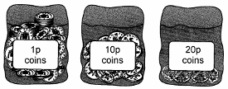

Complete this table to show how many coins are in each bag.

One has been done for you.

|  |  |
| --- | --- |
| Type of coin | Number of coins |
| **1p** | **160** |
| **10p** |  |
| **20p** |  |

1 mark

**14.** Write **two numbers**, each **greater than 100**, to complete this subtraction.



1 mark

**15.** Calculate **1202 + 45 + 367**

|  |
| --- |
|  |

1 mark

**16.** Calculate **8.52 – 7.78**

|  |
| --- |
|  |

1 mark

**17.** Write in the missing digits.



1 mark

**18.** Jemma thinks of a number. She says,

***'Add 3 to my number and then  
multiply the result by 5  
The answer is 35'***

What is Jemma's number?

|  |
| --- |
|  |

1 mark

Riaz thinks of a number. He says,

***'Halve my number and then add 17  
The answer is 23'***

What is Riaz's number?

|  |
| --- |
|  |

1 mark

**19.** Calculate **1025 – 336**

|  |
| --- |
|  |

1 mark

**20.** Calculate 13.6 – 2.8

|  |
| --- |
|  |

1 mark

**21.** Circle **two** numbers which **add** to make **0.12**

**0.1** **0.5** **0.05** **0.7** **0.07** **0.2**

1 mark

**22.** Nadia is working with **whole** numbers.

She says,

**'If you add a two-digit number to a two-digit number  
you cannot get a four-digit number'.**

Is she correct? Circle Yes or No.  **Yes / No**

Explain why.

...............................................................................................................................

...............................................................................................................................

1 mark

**23.** There are 104 children at Delton School

48 children are girls

(a) How many are boys?

1 mark

(b)

|  |
| --- |
| Explain how you worked this out. |

1 mark

**24.** Here are five number cards.



Use all five cards to make an addition that has the **answer 500**

1 mark

**25.** Calculate 808 – 512

|  |
| --- |
|  |

1 mark

**26.** Write what the **two missing digits** could be.



1 mark

**27.** In the chart any **three** numbers in a line, **across or down,** have a **total of 18.45**

Write the **missing** number.





2 marks

**28.** Here are five number cards.



A and B stand for two **different** whole numbers.

The sum of all the numbers on all five cards is 30

What could be the values of A and B?



1 mark

**29.** Calculate **15.05 – 14.84**

|  |
| --- |
|  |

1 mark

**30.** Write in what the missing numbers could be.

170 +  = 220 – 

1 mark

**31.** Calculate **8.6 – 3.75**

|  |
| --- |
|  |

1 mark