**Chocoholics**

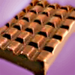

George and Jim want to buy a chocolate bar. George needs 2p more and Jim needs 50p more to buy it.

When they put their money together, it is still not enough to pay for the chocolate bar.

How much is the chocolate bar?

51p