**The Egyptian Method**

Example: 34 x 13 (so we need 13 lots of 34)

1. Start by writing 1 lot of 34.

**1 34**

1. Now write 2 lots of 34 below. Double 34.

**1 34**

**2 68**

1. Now 4 lots of 34. Double 68.

**1 34**

**2 68**

**4 136**

1. Now 8 lots of 34. Double 136.

**1 34**

**2 68**

**4 136**

**8 272**

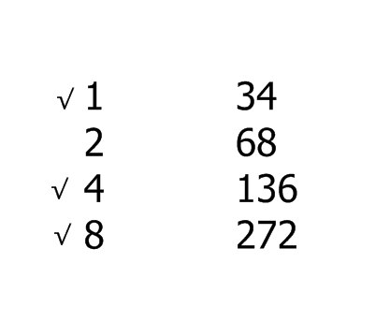

1. We need 13 lots of 34. So we can use the 8 + 4 + 1 = 13.
2. So we add up 34 + 136 + 272 = 442.

This is the answer!

Now try these:

1. 24 x 13
2. 45 x 14
3. 32 x 21
4. 55 x 22
5. 122 x 15
6. 214 x 42