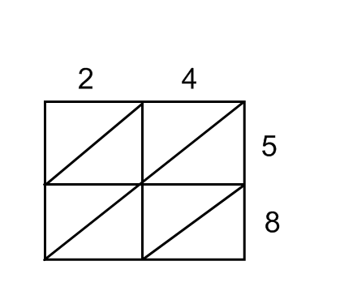**The Gelosia Method** (Sometimes called the Chinese or Indian Method)

Example 24 x 58

1. Draw a 2 x 2 grid as seen here
2. 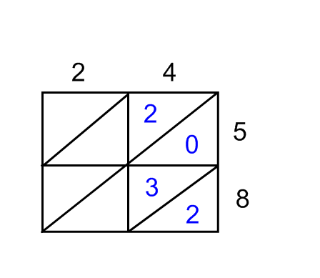Next, you multiply the numbers together to fill in the boxes. You separate the answer either side of the diagonal line.

For example, 4 x 5 = 20 and 4 x 8 = 32

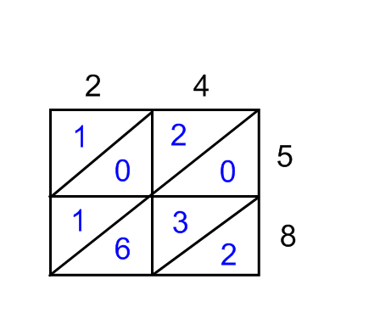

1. Now complete the rest of the boxes. It should look like this:

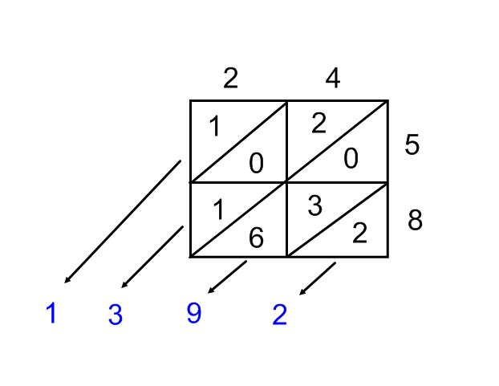

1. Now we add the diagonals up to give us the answer. We start on the right and work across.

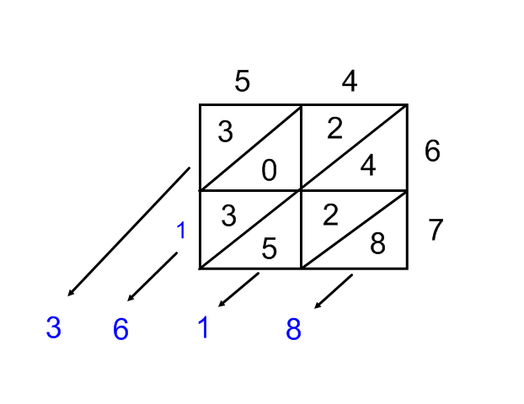Note: If the diagonal adds up to more than 9 you need to ‘carry’ the 1. In the example below the second diagonal adds up to 11. We ‘carry’ the 1 the third diagonal as you can see here.

Now have a go at these. You may want to check your answers on calculators.

1. 34 x 26
2. 48 x 32
3. 72 x 53
4. 91 x 30
5. 55 x 83

What about these? You need to draw a 3 by 2 box.

1. 127 x 32
2. 163 x 43
3. 212 x 58
4. 332 x 37

And these?

1. 420 x 127
2. 392 x 912