**The Russian Method**

Example: 24 x 56

1. Write down the 2 numbers in separate columns. Then you halve one number and double the other number. If the number you are trying to halve is odd, then subtract 1 first and then halve it.

24 | 56

12 | 112

6 | 224

3 | 448

1 | 896

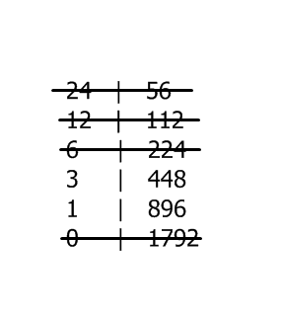0 | 1792

1. Now cross out any row that has an even number in the left column.
2. Now add up the numbers that are remaining in the right column.

448 + 896 = 1344

This is your answer!

Now try these:

1. 34 x 24
2. 18 x 15
3. 28 x 62
4. 68 x 48
5. 20 x 124
6. 126 x 55