WJEC C1 June 2008
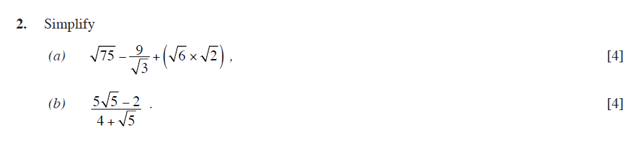
WJEC C1 January 2009
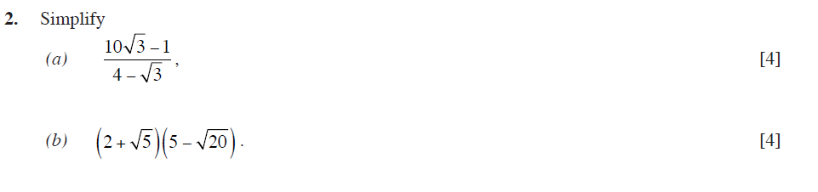
WJEC C1 June 2009

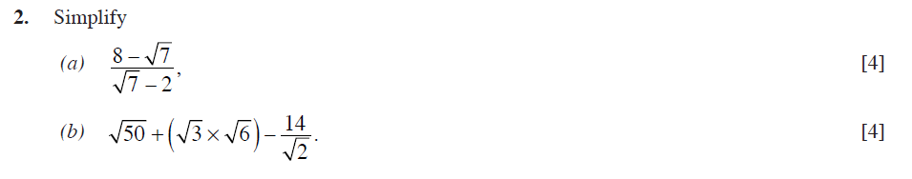
WJEC C1 January 2010
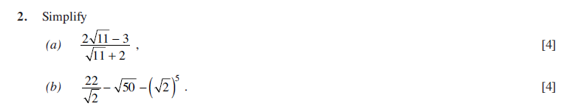
WJEC C1 June 2010
