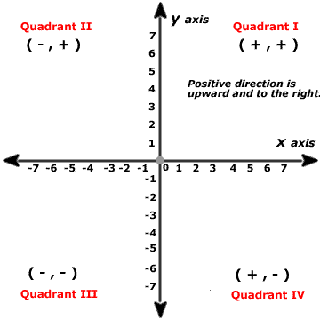**Geometrical Square Rooting**

Follow the instructions below to work out a square root without a calculator! You will need a ruler, compass and pencil only…

Calculating the square root of 9 geometrically…

1) Draw a straight horizontal line of length 9cm. Make sure you leave space above it…

2) Mark the right hand end of the line with an X

3) Draw a line of 1cm from X in the same direction as the original line (so the line is now 10cm long, with an X near one end)

4) Place the point of your compass on the middle of the line (make sure you measure it), and draw a semi-circle over the line, starting at one end and finishing at the other

5) Draw a line from X, vertically up to the semi-circle

6) Measure the length of this line. It should be the square root of 9 if you have been accurate!

Use the same method to estimate the following square roots. The only thing you need to change is the length of the original line!

a) √4 = ____ b) √8 = ____ c) √12 = ____

d)√7 = ____ e) √5 = ____ f) √10 = ____

g) √6 = ____ h) √14 = ____ i) √20 = ____

**ANSWERS**

a) 2

b) 2.83

c) 3.46

d) 2.65

e) 2.24

f) 3.16

g) 2.45

h) 3.74

i) 4.47