Calculator Crossword

Do the number clues using your calculator. Turn the calculator upside-down to see a word. Write down the **word** answers in the correct spaces (answers on page 50)

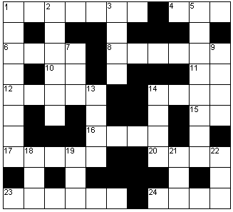

|  |  |  |  |  |  |
| --- | --- | --- | --- | --- | --- |
| **Across** | | | **Down** | | |
|  | **Word clues** | **Number clues** |  | **Word clues** | **Number clues** |
| **1** | To do in spare time | 484 + 1022 - 42 | **1** | The Big Cheese | 7420 x 7422 + 1182 – 30 |
| **4** | The fairer gender | 25% of 1380 | **2** | A nice way to eat 20 across | 0.034 x 11 – 0.00292 |
| **6** | Egyptian goddess | 1/3 of 15453 | **3** | Otherwise | (360 – 2.7) x 10 |
| **8** | 3-D filled objects | 50.19 – (5 x 0.0039) | **5** | A prickly customer | 95092 + 39 - 1730 |
| **10** | ….. and behold | 49/70 as a decimal | **7** | A dotty request for help | 1/3 of 1515 |
| **11** | ….. on, I dare you! | 5 : 3 = 1 : …… | **9** | On your own | 70.5% as a decimal |
| **12** | To sanctify | 5% of 1107560 | **13** | A sorrowful gasp | 712 – (112 + 5) |
| **14** | Under your shoe | 862 – 82 + 2 | **14** | Dig and make one | (152 x 17) - 112 |
| **15** | A short laugh |  | **18** | Slang for lavatory | 7 : 100 = ……. : 1 |
| **16** | Fish use these | 3/7 of 18011 | **19** | Cry a great deal | -195 + 103 |
| **17** | Water does this | 3/5 of 75125 | **21** | To put in hair? | - 61 |
| **20** | Hens lay these | 121/2% of 47944 | **22** | Not stand. |  |
| **23** | Turkeys make this noise | 616 x 615 - 31 |  |  |  |
| **24** | A slit | 13/40 as a decimal |  |  |  |

Answers:

The words you should have found are:

**Across:** **1** Hobbies; **4** She; **6** Isis; **8** Solids; **10** Lo; **11** Go; **12** Bless; **14** Heel; **15** Ho; **16** Gill; **17** Slosh; **20** Eggs; **23** Gobble; **24** Slot.

**Down:** **1** He is boss; **2** Boiled; **3** Else; **5** Hedgehog; **7** SOS; **9** Solo; **13** Sigh; **14** Hole; **18** Loo; **19** Sob; **21** Gel; **22** Sit.