- In 2006 Mr and Mrs Mann paid £420 for their car insurance. The cost of insurance has risen by 4% each year. How much do they pay in 2011?

- The South American Tree Octopus is an endangered species. Conservationists claim that the number falls by 15% each year. There were an estimated 4000 SATO’i at the end of 2007. If the claims are true, how many SATO’i remained at the end of 2010?

- The population of Bodflikistan is growing at a rate of 8% per year. What was the population at the end of 2010 if it was 1,825,000 at the end of 2000?

- Eileen Dover puts £545 in a savings account offering compound interest at 5.2% p.a. How much is there in her account after 4 years?

- Anna Rack borrows £2000 from her bank for 3 years at 8.3% p.a. What is the total amount that she must repay?

- House prices in Llanfairpwllgwyngyllgogerychwyrndrobwllllantysiligogogoch are going up by 5% a year. A house is valued at £127,000. What should its value be in three years’ time?

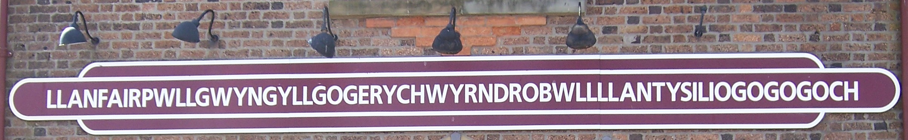

- A ball bounces to a height 20% lower than its previous bounce.
- If the ball is dropped from a height of 150cm, how high is its first bounce?
- Which is the first bounce to a height less than 20cm?

- In 1996, a plague of billions of mice developed in Australia, due to unusually warm conditions and a surplus of food. On 1 January it is estimated that on one particular farm there were 40 mice. Over the next twelve months, the number of mice increased at a rate of 118% per month. How many mice occupied the farm at the end of this period?

- In a particular incident during the American War of Independence (1775), a careless British soldier damaged an unlucky American farmer’s fence. It was estimated that this cost the farmer the equivalent of £6. In 1965 a descendant of the farmer tried his luck and billed the British Government for the amount which (he claimed) had accumulated at 5% per year.

How much was British Government billed? (The end of the story? The British Chancellor of the Exchequer paid the American £6 out of his own pocket)

